**Question:1**

**I have created** [**data.py**](http://data.py) **which contains dictionary**   
  
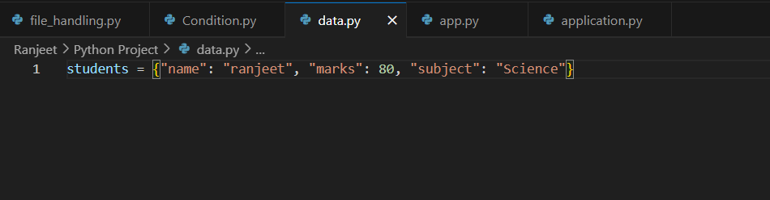

**I have created Code which import this dictionary and route would be /api**   
  
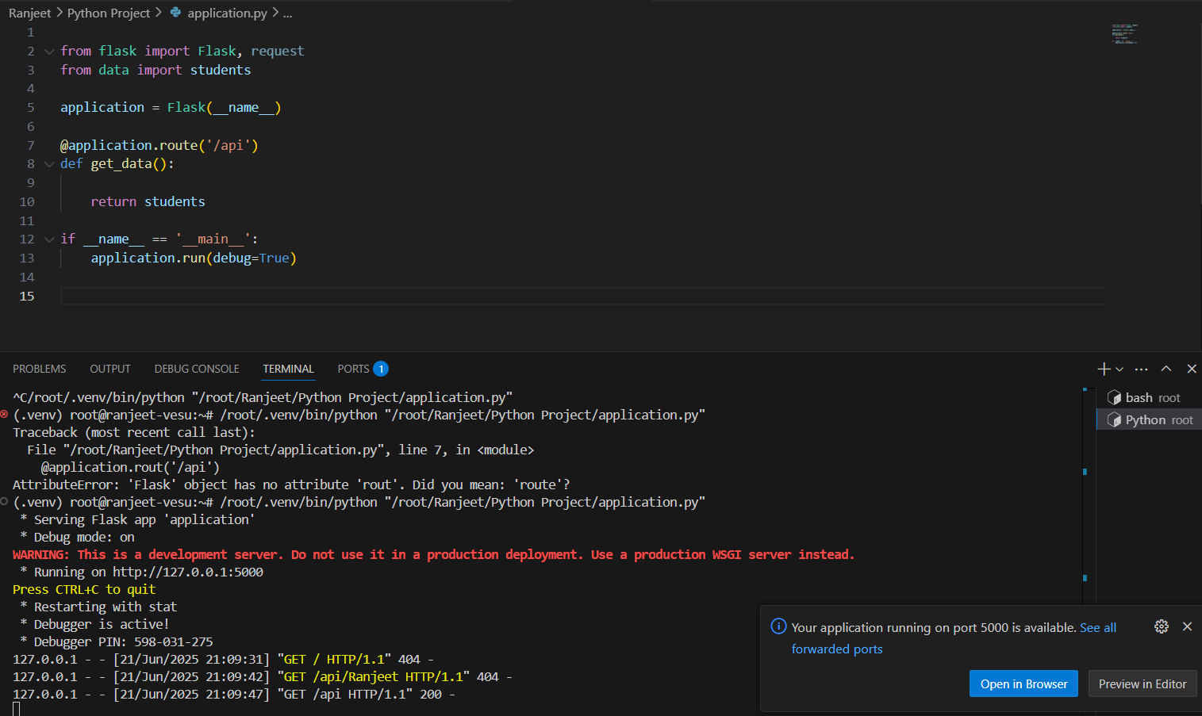

**Here is the output.**  
  
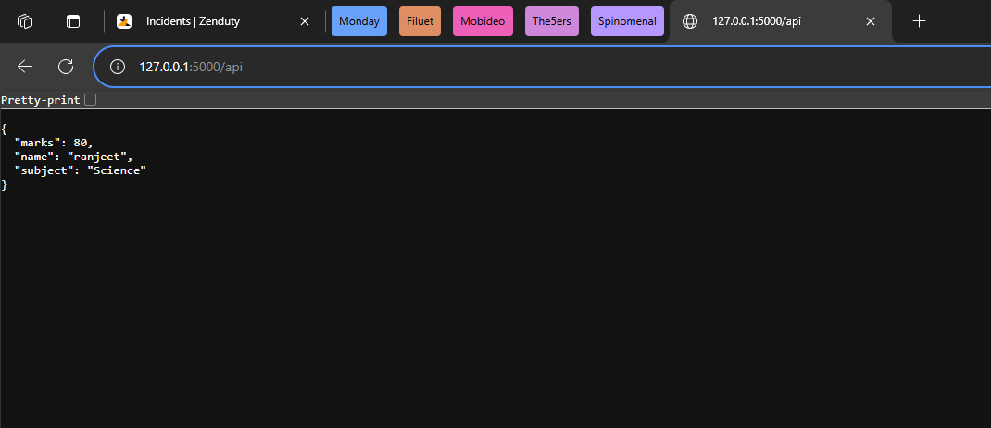

**Question 2:**  
  
**I have created flask project which is below :**  
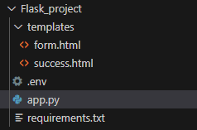  
  
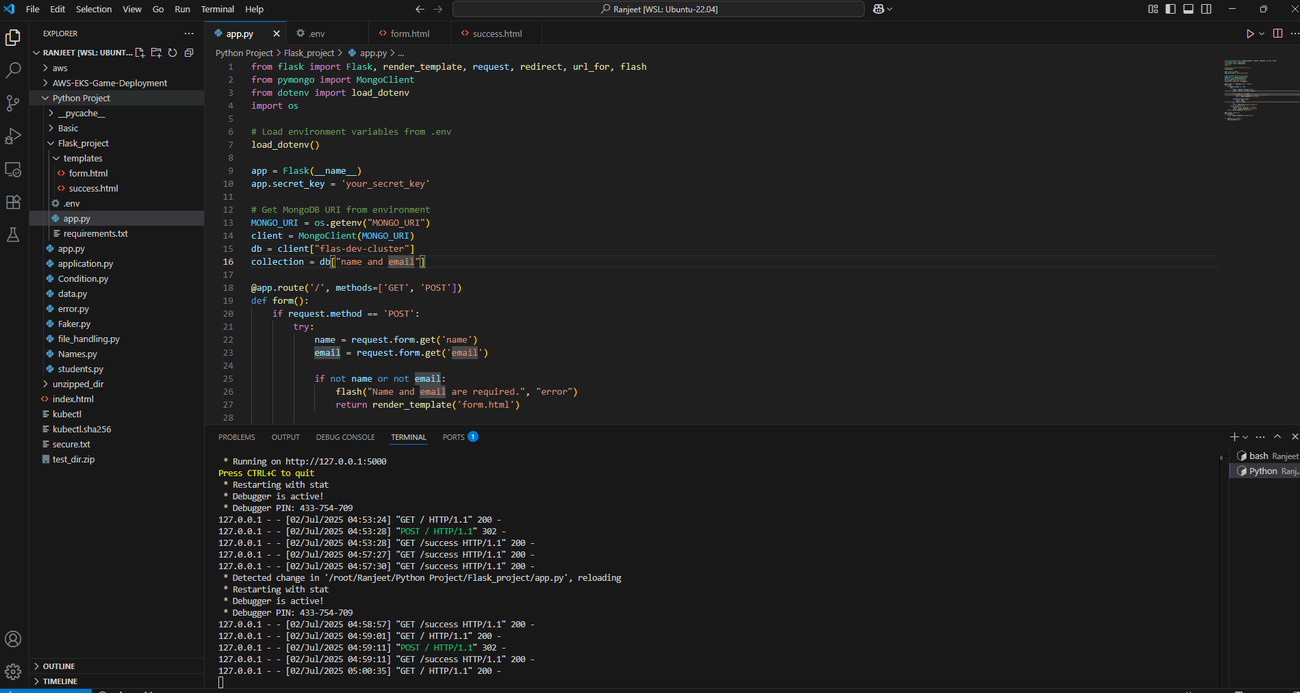

App can connect on : localhost:5000

  
I have submitted the data   
  
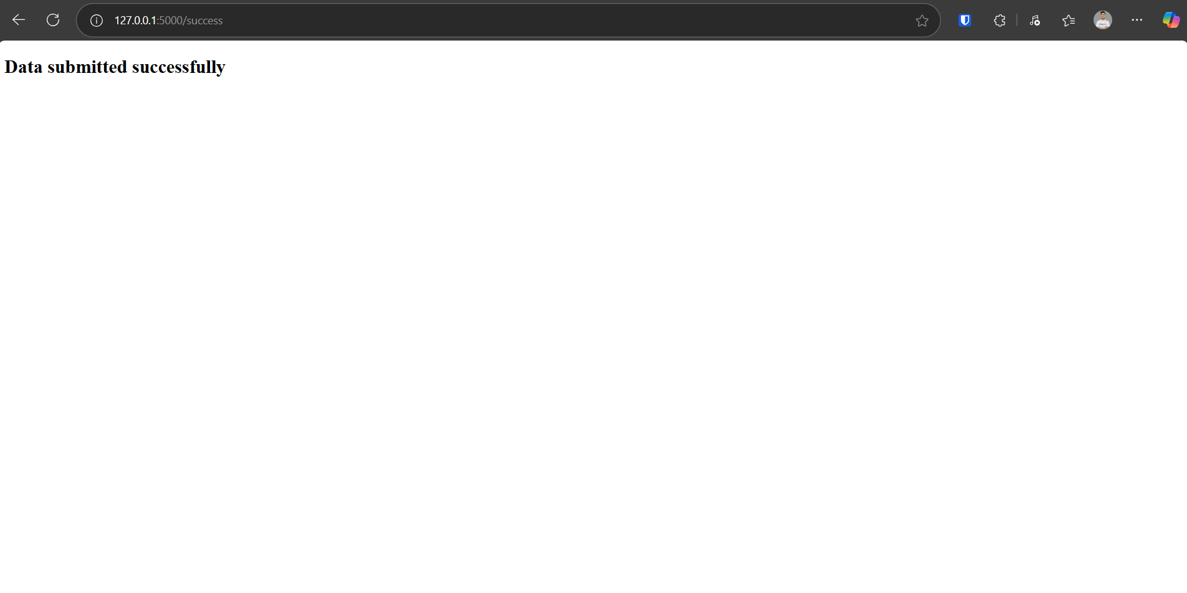  
We can see entry in the DB   
  
